 Trader Guidelines

1. Go to the Homepage of the website and click on the register link that is visible in the top right side of the screen as shown in the image below

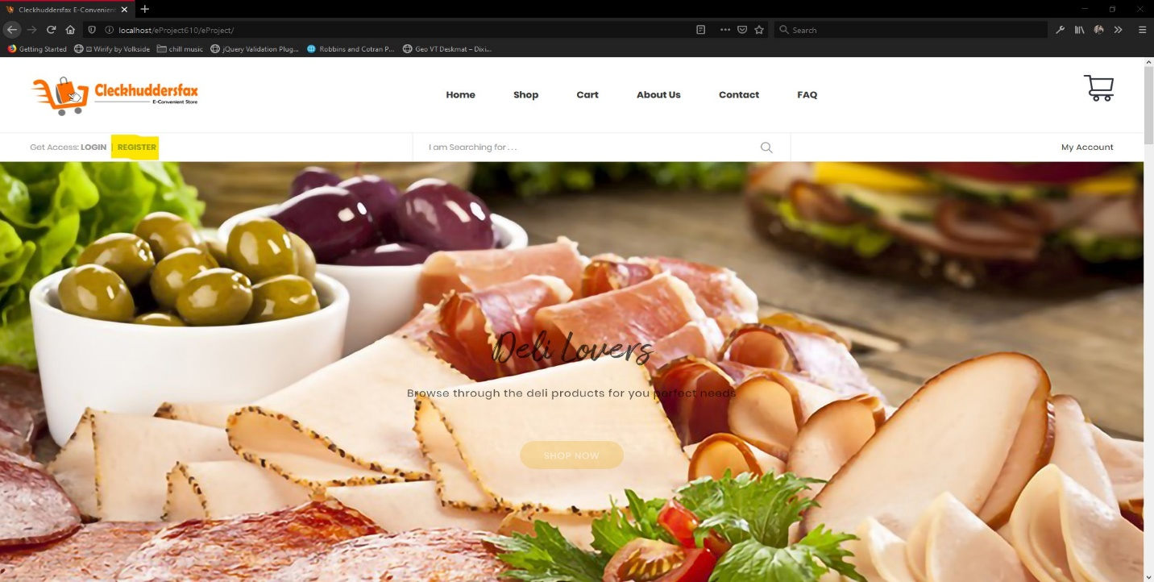

1. After you click the register button you will be redirected to the register page where you can fill out the data required by the form and make sure to select the trader option from the drop-down menu

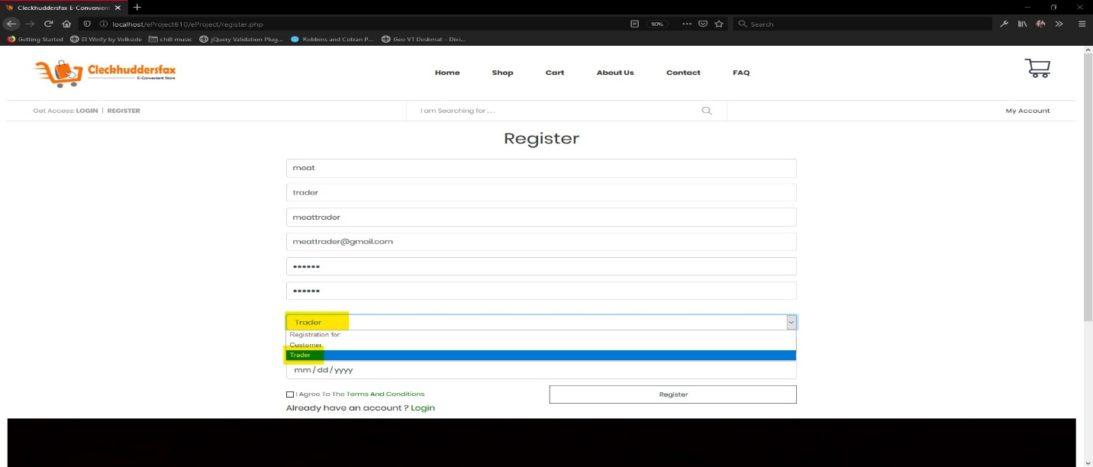

1. After filling out the form you can read the terms and condition from the link given beside the checkbox and after you have read the terms and condition make sure to check the checkbox 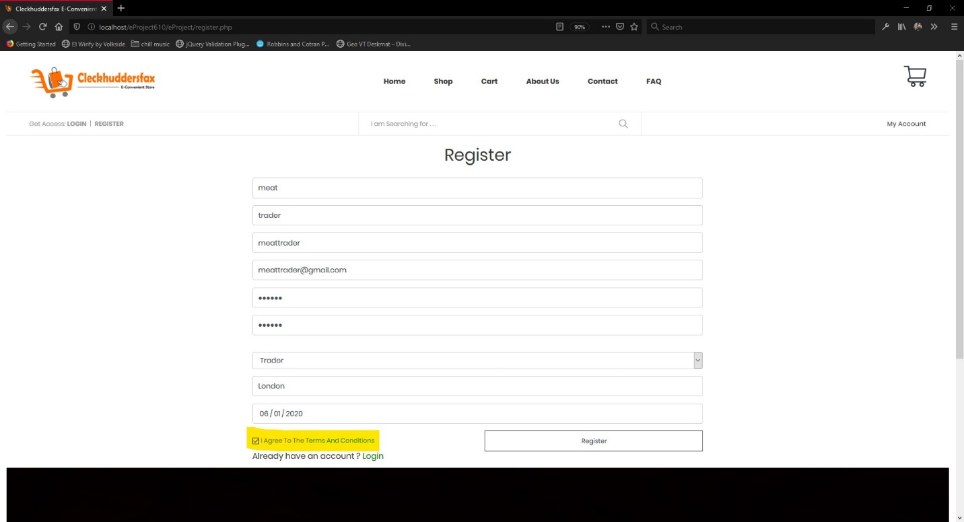
2. Click on the Register Button to Continue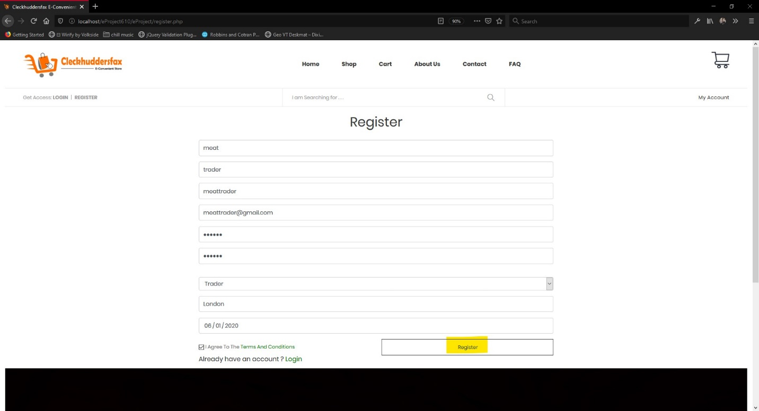
3. After you click on the Register button you will be prompted to enter a short description about the product you are about to sell on the website click on the submit button after you have entered the description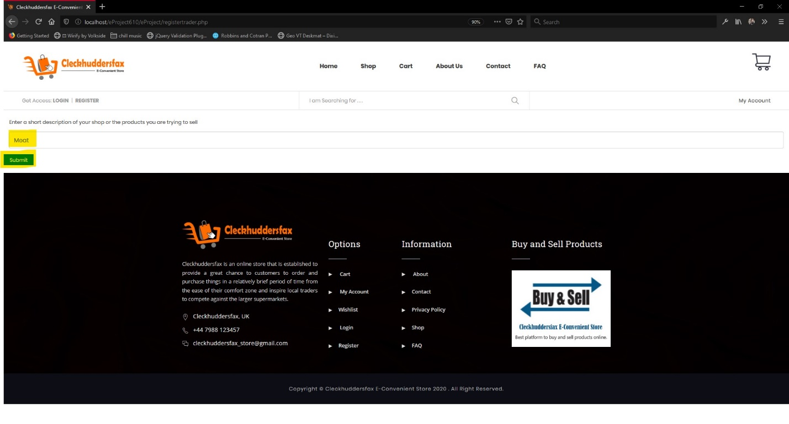
4. After you have clicked on the submit button you will again be redirected to the register page and you will get the message as shown in the figure and you will receive a mail with the description you added in the previous step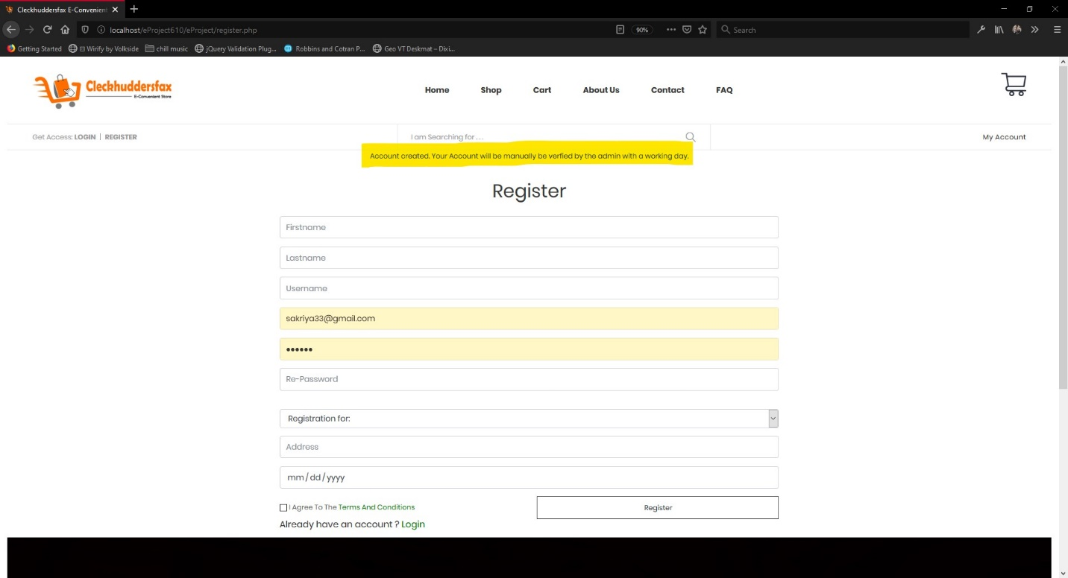
5. Then your account must be manually verified by the admin in order to login
6. Head to the login link seen on the top right of the screen as shown in the image

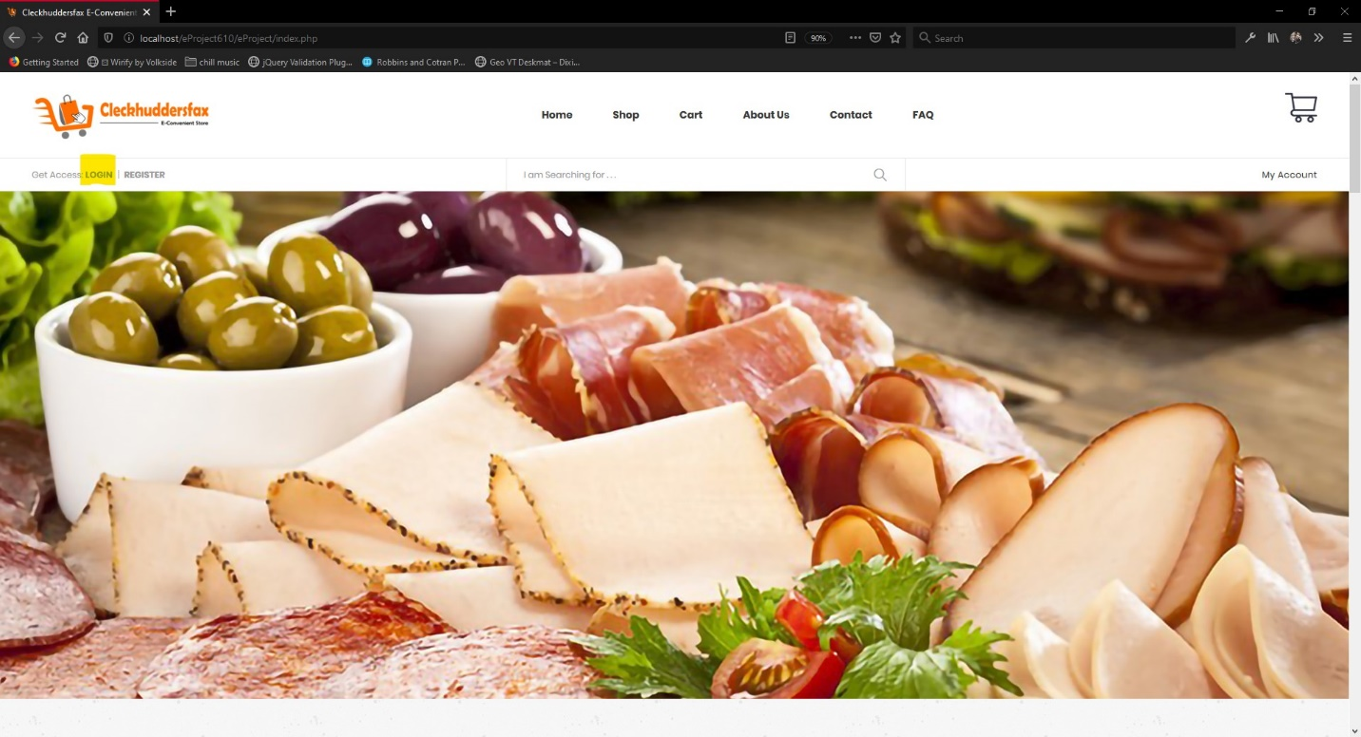

1. You will then be Redirected to the login page and you can enter the email address and the password that you entered in step 6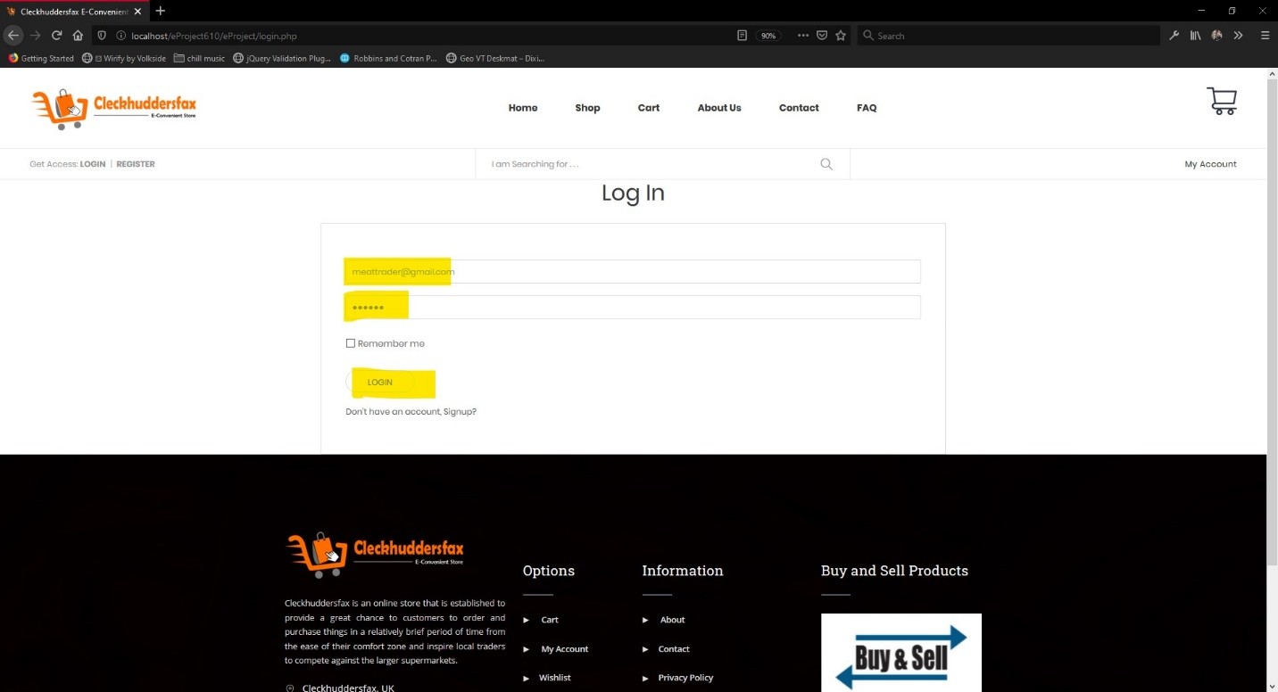
2. If your account is not verified by the admin then you will get the following error message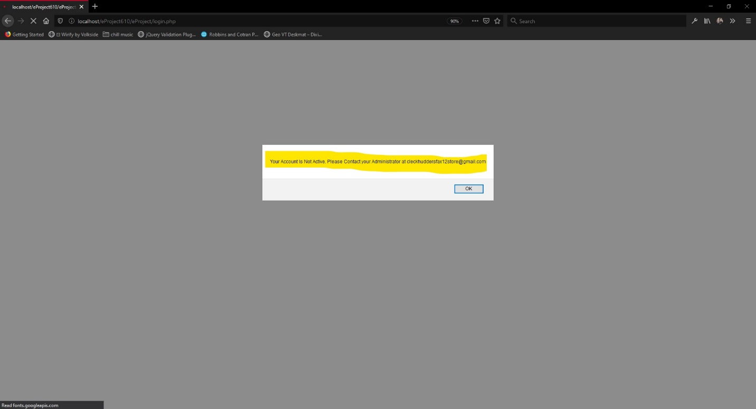
3. If you are verified by the admin then you will be redirected to the Trader dashboard as shown in the image below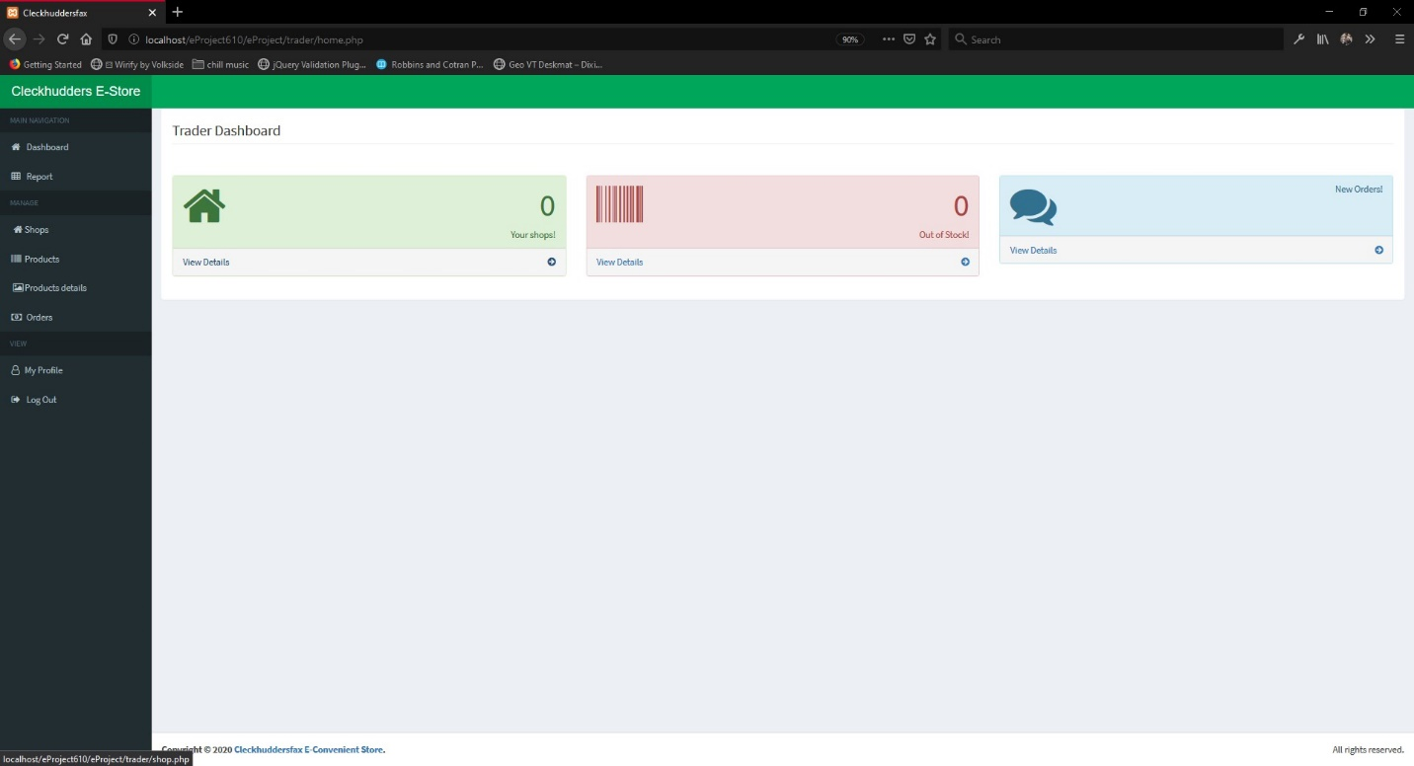
4. After you have logged into the Trader Dashboard you must create a shop in order to proceed head to the shops link as marked in the image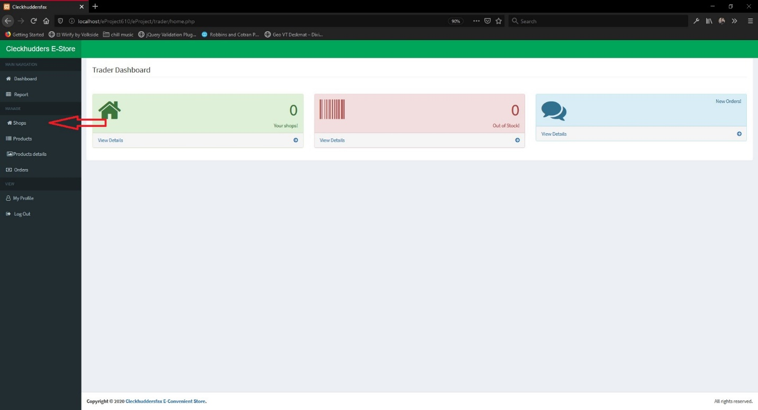
5. After you click on the link the following page will appear and then click on new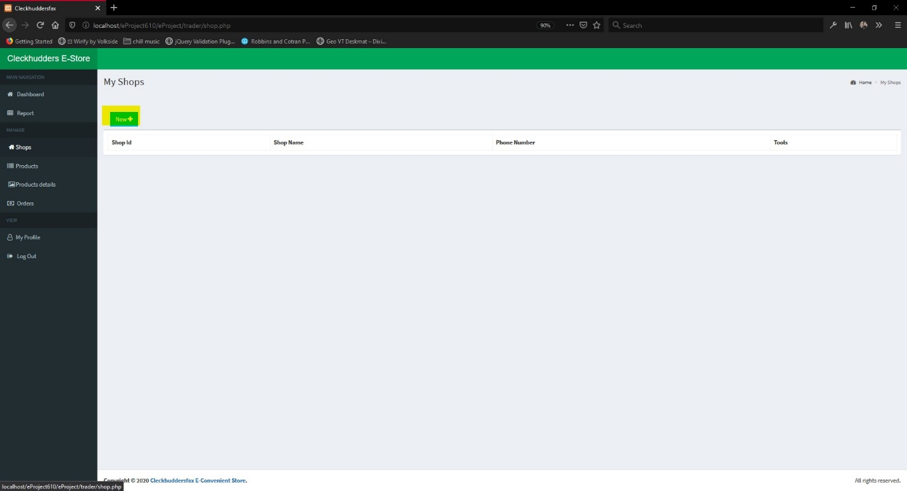
6. After you click on new the following form will appear where you can create a new shop enter the details and click on add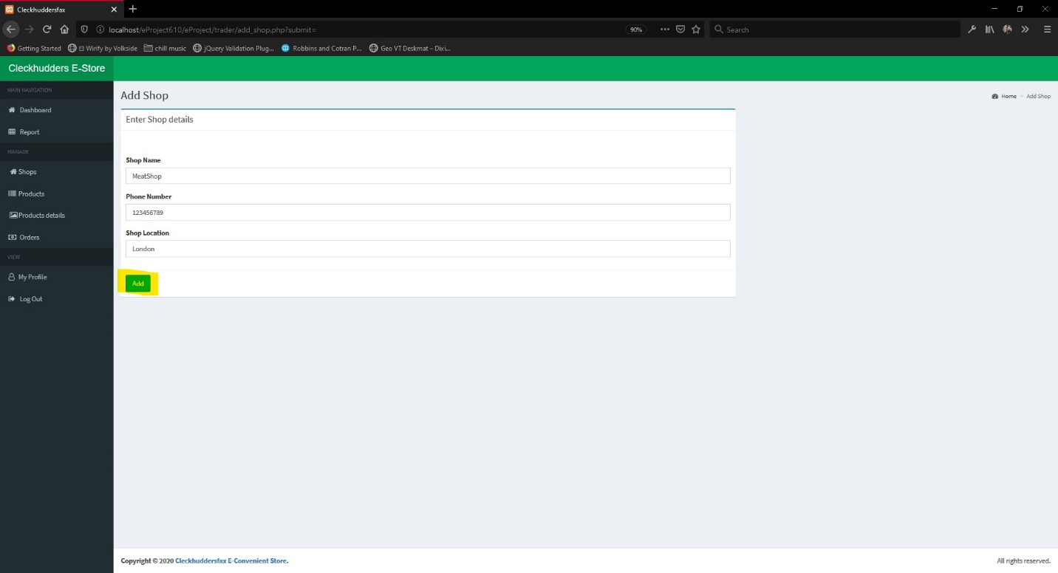
7. After you click on add the following message should appear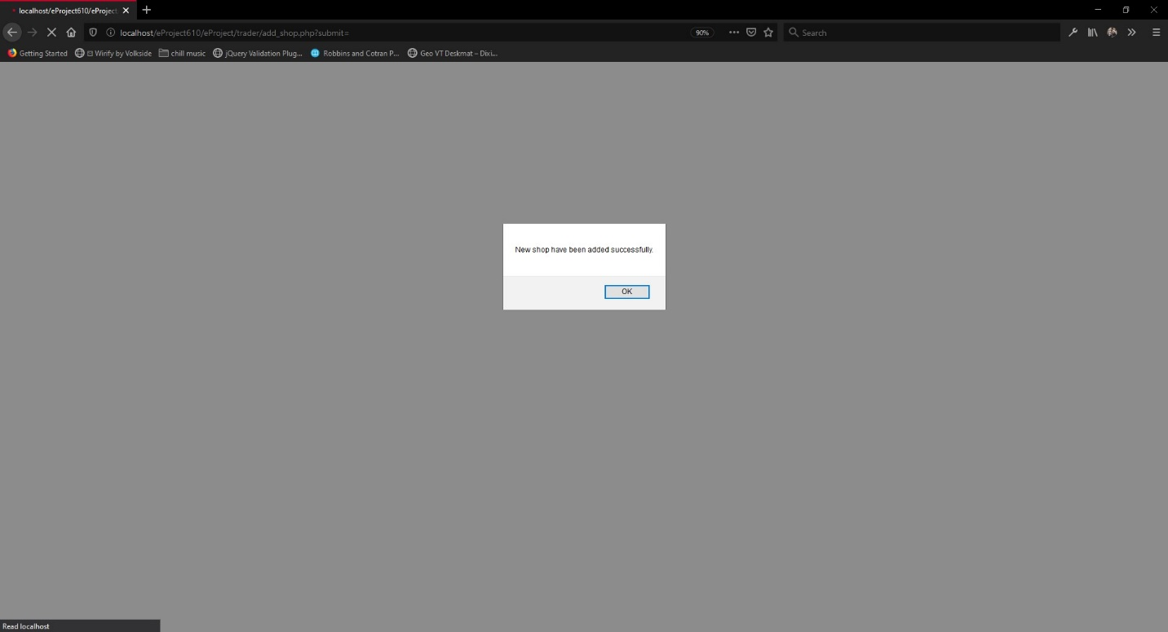
8. Click on OK and the shop you just added will be displayed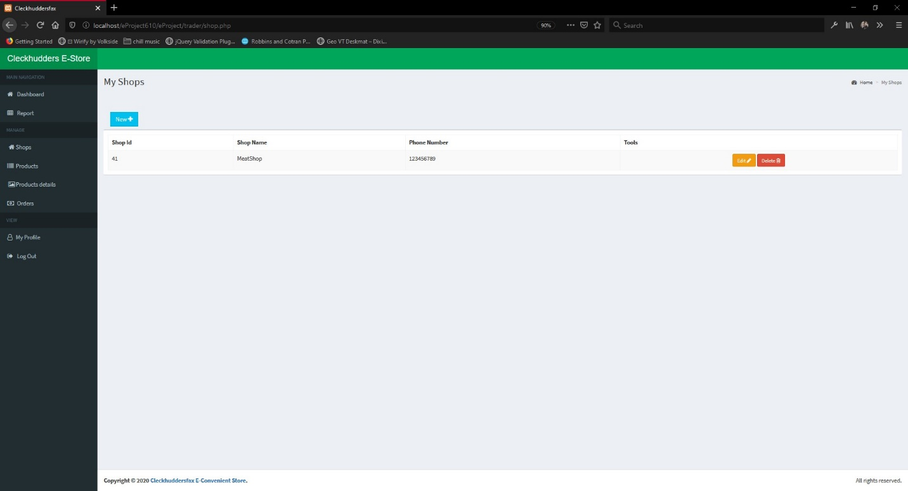
9. Then in order to add new products via that shop click on products 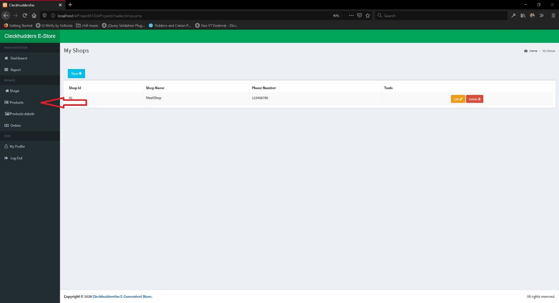
10. After you click on products the following page will appear and then click on new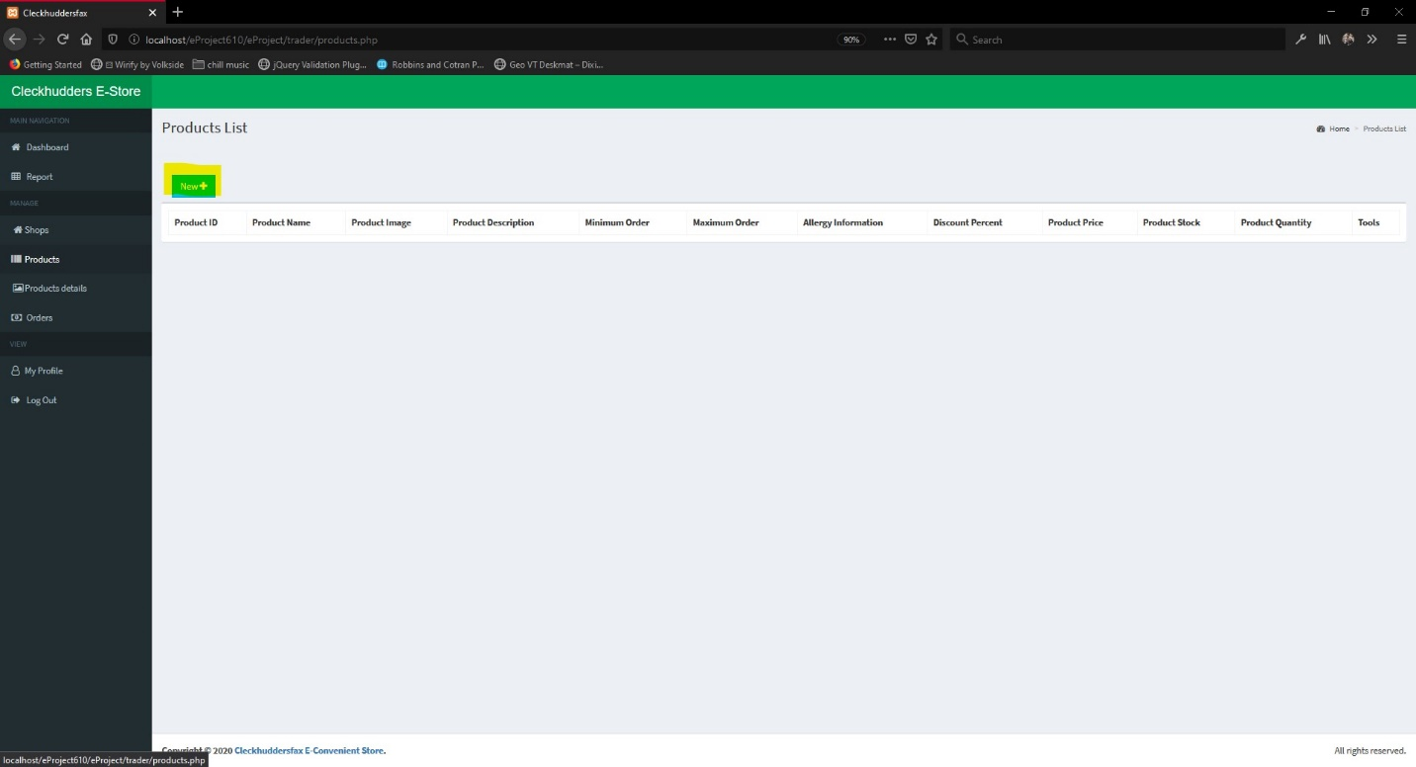
11. After you click on the new button the following page will appear fill out the form choosing the shop that you have just created and click on browse to select he image that you want to add for the product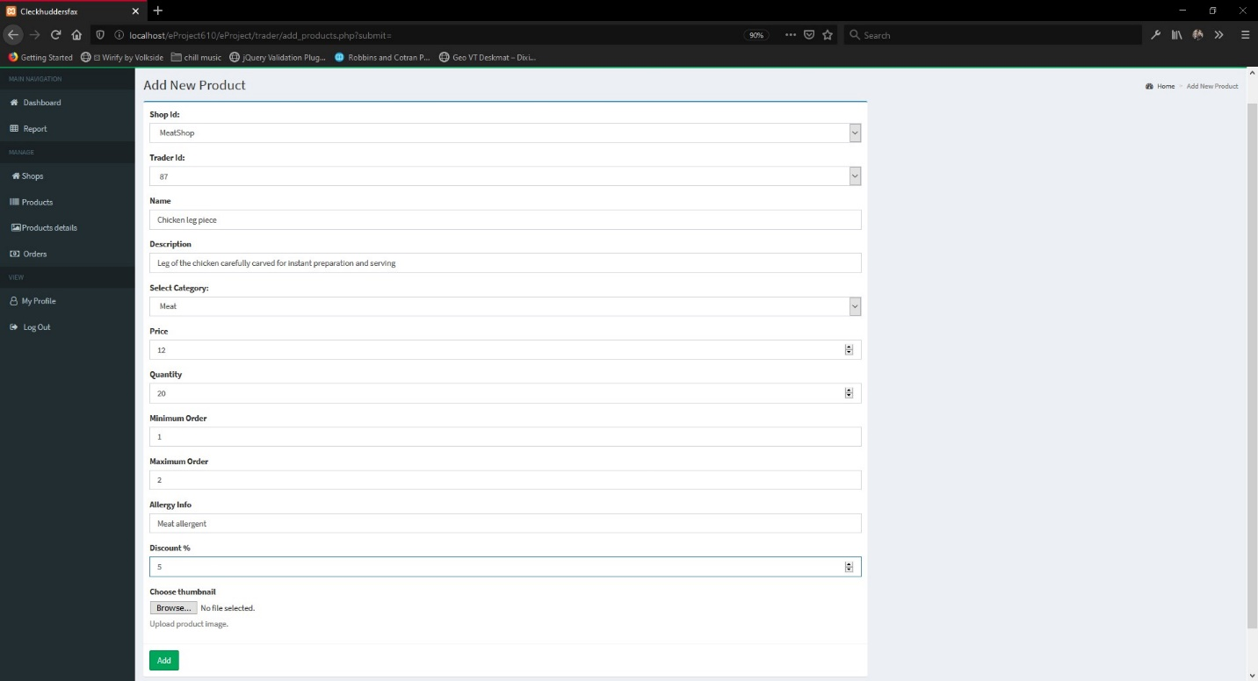
12. After you click on the browse button a dialog box will appear to choose the image choose the image and click open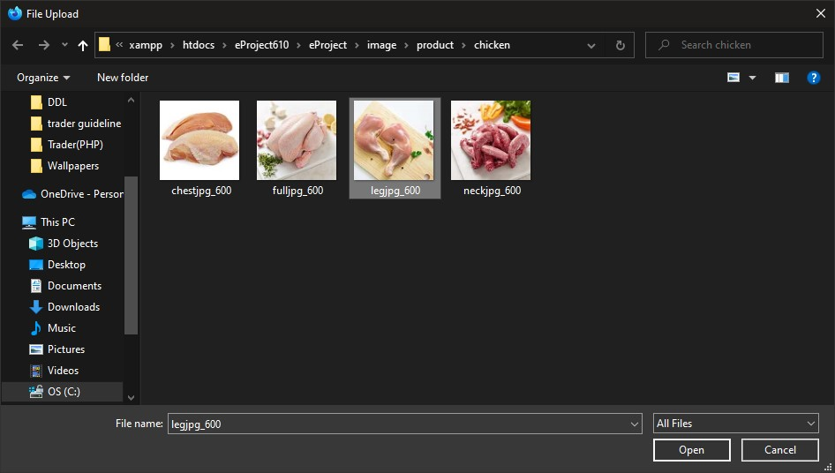
13. Then the image you want will be added then click add
14. You will get the following message after you product has been added successfully click on ok and you will be redirected to the productsdetails page where you can see all the products that you have added and tools that you can use to either edit the product or delete the product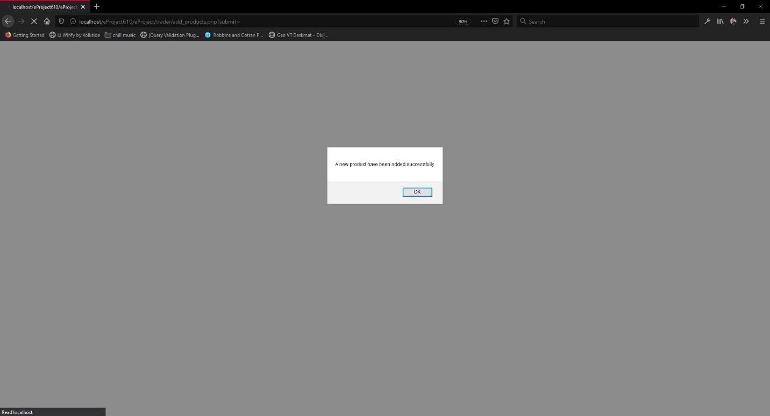

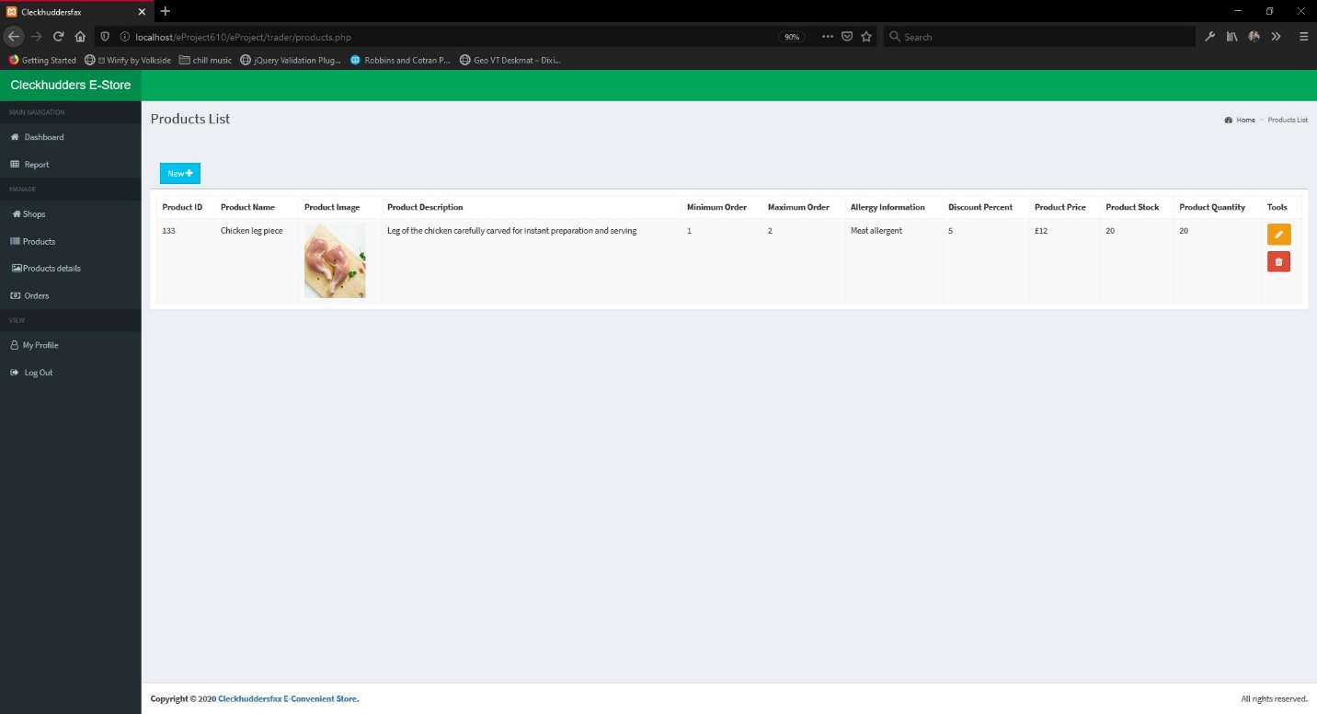

1. To edit the products click on the pencil icon on the left side of the product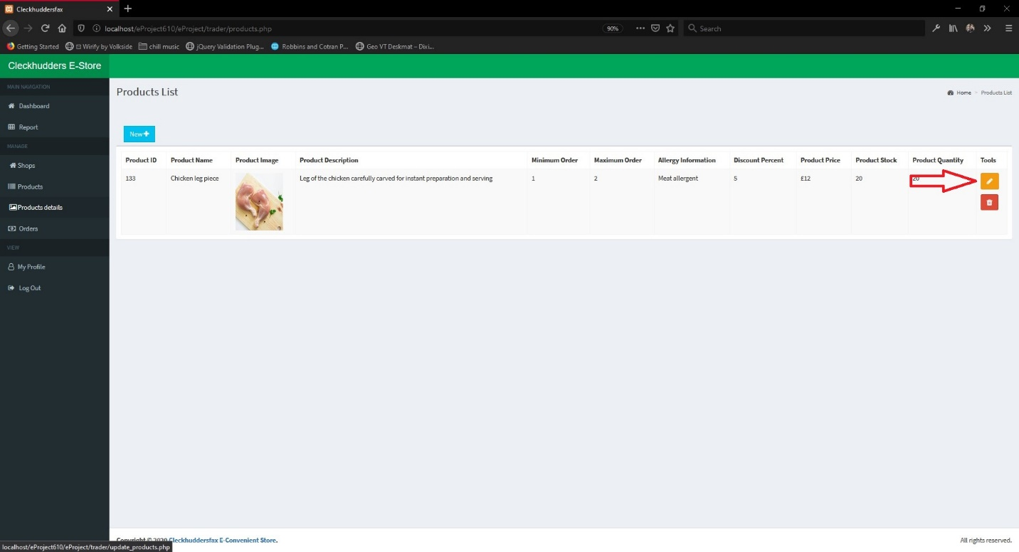
2. Then the following form will appear and change the details you want to change and click on update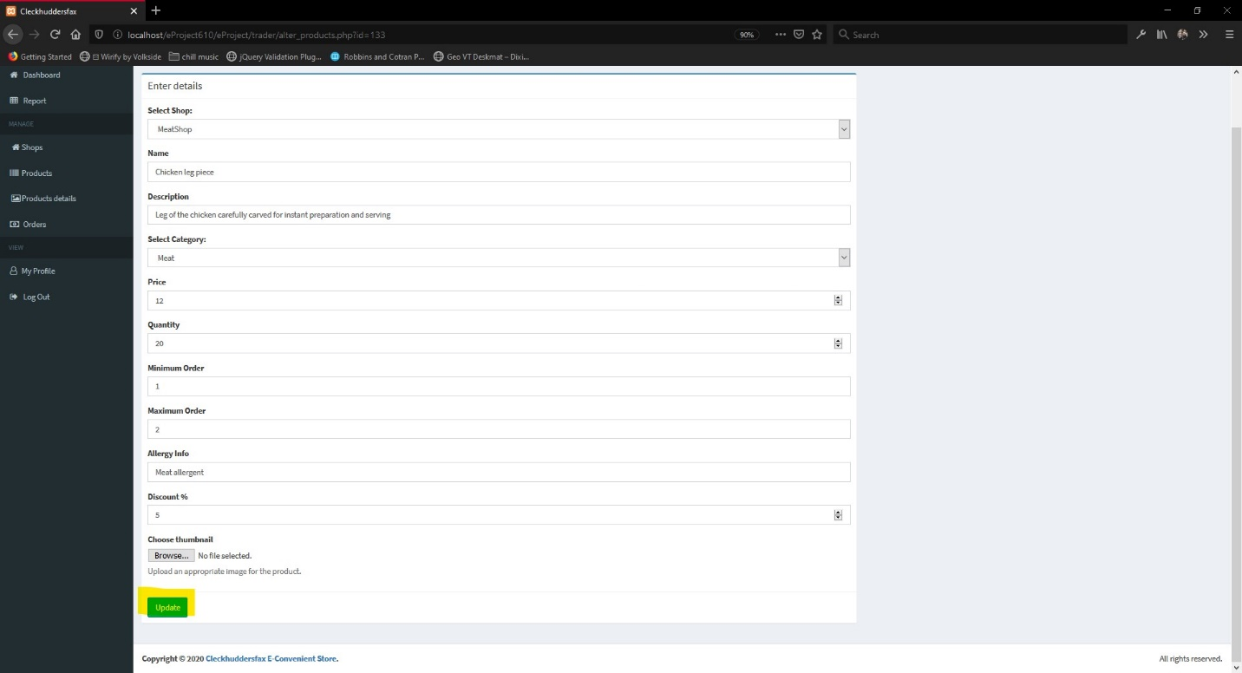
3. Orders of your product will appear in the orders link marked in the image the status of the order is shown and what has been ordered along with the delivery date pickup time. If you have delivered the item then click on the DELIVERED button as marked in the image